There is a square field with each side 500 metres long. It has a compound wall along its perimeter. At one of its comers, a triangular area of the field is to be cordoned off by erecting a straight line fence. The compound wall and the fence will form its borders. If the length of the fence is 100 metres, what is the maximum area in square metres that can be cordoned off?
1. 2,500
2. 10,000
3. 5,000
4. 20,000
A rectangle PRSU, is divided into two smaller rectangles PQTU, and QRST by the line TQ. PQ=10cm, QR = 5 cm and RS = 10 cm. Points A, B, F are within rectangle PQTU, and points C, D, E are within the rectangle QRST. The closest pair of points among the pairs (A, C), (A, D), (A, E), (F, C), (F, D), (F, E), (B, C), (B, D), (B, E) are 10 cm apart.
87. Which of the following statements is necessarily true?
1. The closest pair of points among the six given points cannot be (F, C)
2. Distance between A and B is greater than that between F and C
3. The closest pair of points among the six given points is (C, D), (D, E), or (C, E)
4. None of the above
88. AB > AF > BF; CD > DE > CE; and BF = 6 cm. Which is the closest pair of points among all the six given points?
1. B, F
2. C, D
3. A, B
4. None of these
A ladder leans against a vertical wall. The top of the ladder is 8 m
above the ground. When the bottom of the ladder is moved 2 m farther away
from the wall, the top of the ladder rests against the foot of the wall. What
is the length of the ladder?
(a) 10 m (b) 15 m
(c) 20 m (d) 17 m

A certain city has a circular wall around it, and the wall has four
gates pointing north, south, east and west. A house stands outside the city,
three kms north of the north gate, and it can just be seen from a point nine
kms east of the South Gate. What is the diameter of the wall that surrounds
the city?
(a) 6 km (b) 9 km
(c) 12 km (d) None of these

The area of the triangle whose vertices are (a, a), (a + 1, a + 1), (a + 2, a) is:
- a3 2. 1 3. 2a 4. 2 ½

Four horses are tethered at four corners of a square plot of side 14 metres (m) so that the adjacent horses can reach one another. There is a small circular pond of area 20 m2 at the centre. The area left ungrazed is:
- 22m2 2. 42m2 3. 84m2 4. 168m2

The length of the common chord of two circles of radii 15 cm and 20 cm, whose centres are 25 cm apart, is (cm):
1. 24 2. 25 3. 15 4. 20

83. In a triangle ABC, the internal bisector of the angle A meets BC at D. If AB = 4, AC = 3 and A = 600, then length of AD is:
1. 2 \/3 2. 12 \/(3/7) 3. 15 \/(3/8) 4. 6 \/(3/7)

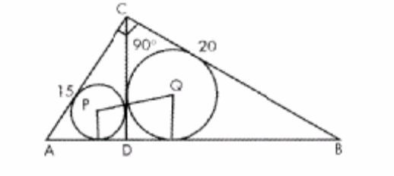

88. In the above figure, ACB is a right angled triangle. CD is the altitude. Circles are inscribed within the triangle ACD, BCD. P and Q are the centres of the circles. The distance PQ is
1. 5 2. \/50 3. 7 4. 8

In the diagram below: LABC = 900 = LDCH = LDOE =LEHK = LFKL = LGLM =LLMN.
AB = BC = 2CH = 2CD = EH = FK = 2HK = 4KL = 2 LM = MN

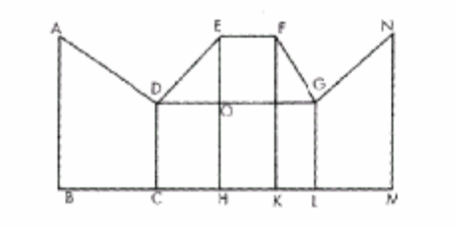

91. The magnitude of LFGO =
1. 300 2. 450 3. 600 4. none of these

Neeraj has agreed to mow the front lawn, which is a 20m by 40m rectangle. The mower mows a 1 m wide strip. If Neeraj starts at one corner and mows around the lawn toward the center, about how many times would he go round before he has mowed half the lawn?
1. 2.5 2. 3.5 3. 3.8 4. 4.0

In the figure given below, ABCD is a rectangle. The area of the isosceles right triangle ABE = 7 cm2. (FC) = 3(BE). The area of ABCD (in cm2) is:
1. 21 2. 28 3. 42 4. 56
Section

